**Exam: Structure, Plasticity and Repair of the Nervous System**

**(UZH: BIO 343, ETH: 376-1305-01L)**

**Date: Monday, January 18th, 2018**

**Location: ETH Hauptgebäude, floor E**

**Exam procedure:**

Due to the high number of students, the PC exam will take place in two consecutive sessions. In order to prevent interactions between students of the two sessions, please follow the following instructions.

**Time: 1st session: 09.00-10.30**

**2nd session: 11.00-12.30**

**Info for 1st Group:**

Dear Students of the first group, your exam will start at 9:00 and end at 10:30. After that you will be asked to move to another room where **Mobile use is still strongly prohibited**! While you are in this room the students of the second group will be introduced in the exam Rooms. Only when all the exam rooms are closed you will be able to leave. This will be at 11:05

**Info for 2nd Group:**

Dear Students of the second group, your exam will start at 11:00 and end at 12:30. Please DO NOT come to the PC-Rooms before 10:55. If you arrive earlier please wait in the main Hall of the ETH Building.

**Important info for all the students**

At the exam you will need to know your nethz-login, bring your 'Legi' and a pen (to sign). If you are bothered by the noise level produced by the keyboards, bring along earplugs.  
The exam will consist of 2 types of questions:

Single Choice Questions

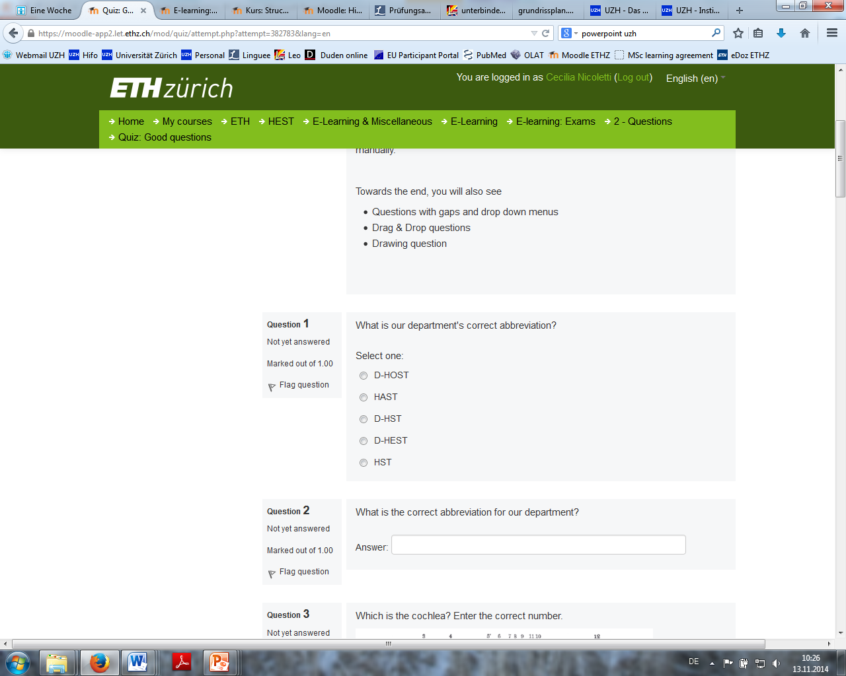

Multiple Choice Questions (K-Prime)

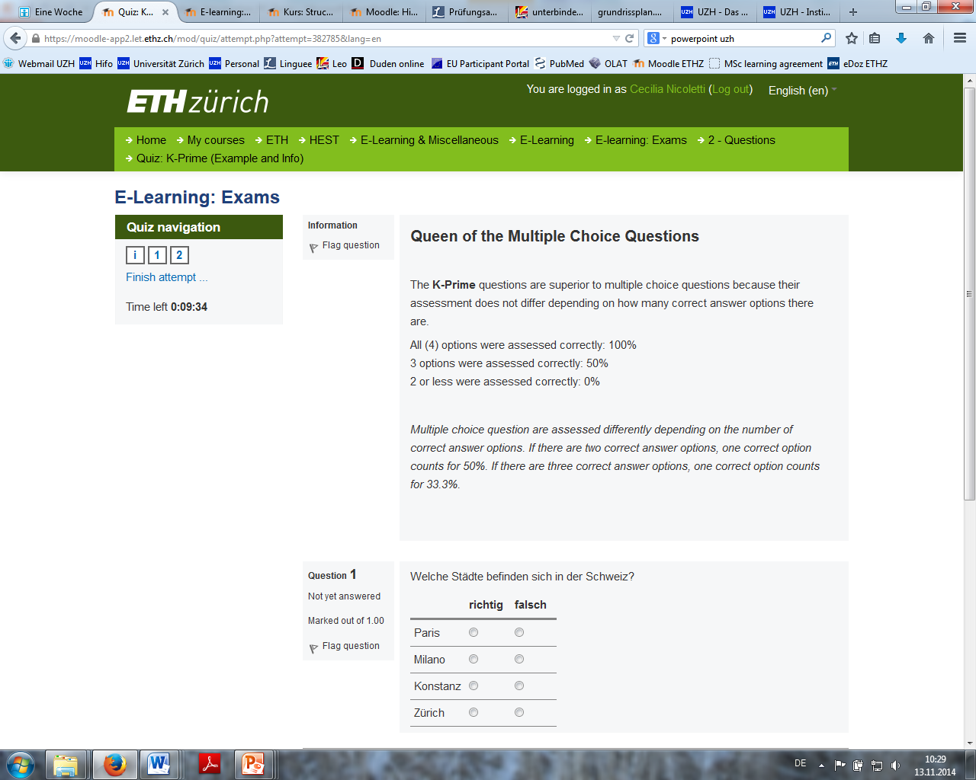

If you have any questions regarding the technical side of the exam, do not hesitate to contact me. You will receive additional information on the grouping at a later time point.  
Kind regards,

Cecilia Nicoletti

**Repetition Exam: Structure, Plasticity and Repair of the Nervous System**

**(UZH: BIO 343, ETH: 376-1305-01L)**

**Date: Thursday, March 1 , 2018**

**Location: ETH Hauptgebäude, floor E**